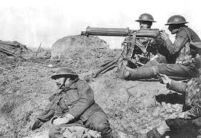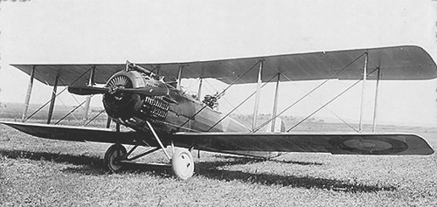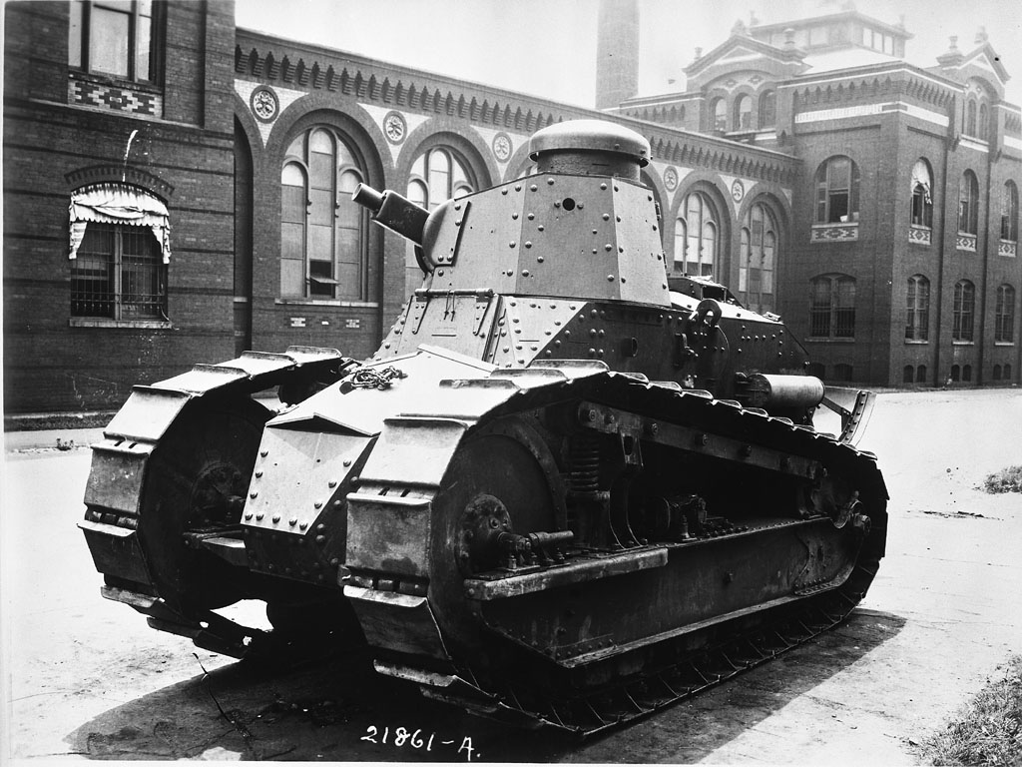

World War I – Weapons Technology

Background: The time of industrialization brought many changes including how weapons were produced and their level of destructiveness. The assembly line idea was applied to the manufacturing of weapons resulting in mass amounts of arms being produced. Industrialization was also a time of new ideas and inventions. These two events, new inventions and the assembly line, combined to create mass destruction in World War I.

Assignment: You will be assigned a new type of weapon that was used for the first time in battle during World War I. You will be given either airplanes, tanks or machine guns. You will look at the evolution of this weapon and its effect on World War I.

Project Requirements:
- One-page maximum infographic using Canva
- Minimum of two pictures
- Short, descriptive sentences or sentence fragments. In other words, do not overwhelm the reader with text. This is not a paragraph; it is hard hitting facts that draw the reader’s attention
- Background design or color can not detract from main message or readability
- Must cover the following:
  - Name of weapon and its purpose
  - Impact on WWI
  - How they were used on the battlefield

Final product is due: _______________________________________________________________________________

WWI Technology Topic: __________________________________________________________________________

Grading Rubrics:

 | 4 | 3 | 2
Content:  Individuals, Groups, and Events that shaped History | In addition to level 3, contains additional features of the weapon | Contains all required historical facts | Partially contains required historical facts
Tech:  Technology Operations and concepts | Uses advanced design elements (borders, graphs, tables, etc.) | Easily readable, one page in length, visually appealing | Design elements detract from main message
PSR:  Work Completion/ Effort and Self-Direction | Turned in on time and demonstrated significant effort and attention to detail. Excellent job with proof reading, capitalization, and spell checking. | All elements of project completed and turn in by due date. | Late or little attention to proofing

